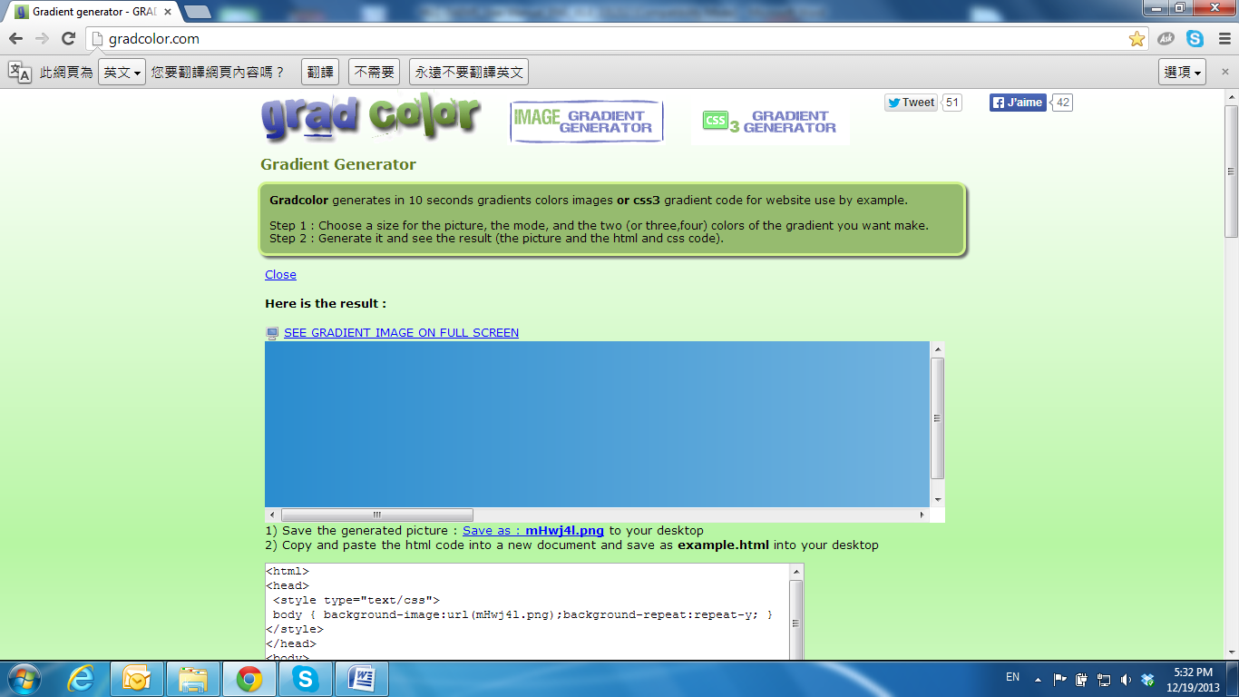

Package Contents

|  |  |  |
| --- | --- | --- |
| IP Camera | Conversion Ring + Screws x6 | Quick Installation Guide |
|  |  |  |
| RJ45 Female to Female | Screws x3 | Wall Plug x3 |
|  |  |  |
| CD |
|  |

• The CD includes user manual and software tools